SPARTA:
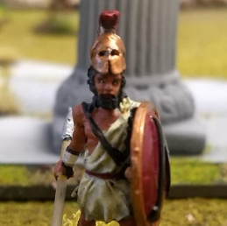
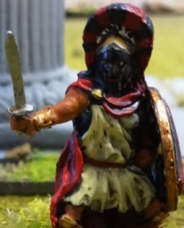
List: Melander the Callous 127
Therides 102
14 Hoplites 378
8 Perioiki 120
11 Helots 77
804 (+3pts)

TYPE | M | R | MEL | M D | AG | BR | ARM | W | EQUIPMENT
Melander the Callous  Sparta A | 6" | +1 | +4 | 2D | +3 | +4 | +1 | 4 | Lg Shield, Helmet, Sword | 127
May reroll failed Will to Fight checks
Wall of Iron* Lethal Blade# Blademaster (Enemy cannot parry) Parry 4* Lethal 3#

LEVEL: 3 EXP: 6

TYPE | M | R | MEL | M D | AG | BR | ARM | W | EQUIPMENT
Therides  Sparta B | 6" | +1 | +3 | 2D | +3 | +4 | +1 | 4 | Lg Shield, Helmet, L Spear, Sword | 102
May reroll failed Will to Fight checks
War Cry Inspire Voice of Command Parry 2 + 1

LEVEL: 2 EXP: 3

TYPE | M | R | MEL | M D | AG | BR | ARM | W | EQUIPMENT
Hoplite | 5" | +1 | +3 | 2D | +1 | 3 | +2 | 2 | Lg Shield, Linothorax, L Spear, Sword | 27
May reroll failed Will to Fight checks Phalanx

TYPE | M | R | MEL | M D | AG | BR | ARM | W | EQUIPMENT
Perioikoi Hoplite | 6" | +1 | +2 | 2D | +0 | +2 | +0 | 1 | Lg Shield, L Spear, Sword | 15
Parry 2 + 1

TYPE | M | R | MEL | M D | AG | BR | ARM | W | EQUIPMENT
Helots | 6" | +1 | +0 | 1D | +1 | +1 | +0 | 1 | Dagger, Slings | 7

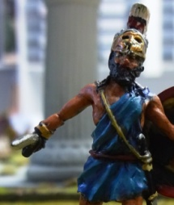
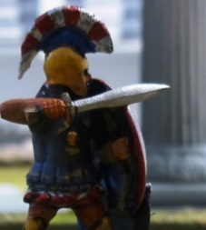
ATHENS:
List: Solactes 87

5 Hoplites 100
7 Archers 70
6 Peltasts 72

Phalomos 67 out one turn
329 (+5pts)

TYPE | M | R | MEL | M D | AG | BR | ARM | W | EQUIPMENT
Phalamos  Athens B | 5" | +1 | +2 | 2D | +1 | +3 | +3* | 2 | Linothorax, Lg Shield, Apron, Sword | 67
Divine Luck Blessed At Birth* Parry 3

LEVEL: 1 EXP: 1

TYPE | M | R | MEL | M D | AG | BR | ARM | W | EQUIPMENT
Soloctates Athens D | 6" | +1 | +2 | 2D | +1 | +3 | +1 | 3 | Lg Shield, Helmet, Sword | 87
Hands of A Healer Medicus Inspire Parry 3

LEVEL: 2 EXP: 3

TYPE | M | R | MEL | M D | AG | BR | ARM | W | EQUIPMENT
Hoplite | 5" | +1 | +2 | 2D | +0 | +2 | +2 | 1 | Lg Shield, L Spear Linothorax, Sword, | 20
Phalanx
TYPE | M | R | MEL | M D | AG | BR | ARM | W | EQUIPMENT
Archer | 6" | +1 | +1 | 1D | +0 | +2 | +0 | 1 | Bow | 10

TYPE | M | R | MEL | M D | AG | BR | ARM | W | EQUIPMENT
Peltast | 6" | +2 | +1 | 1D | +1 | +1 | +1 | 1 | Javelin, Sm Shield, Helmet, Sword. | 12
Hit and Run
TYPE | M | R | MEL | M D | AG | BR | ARM | W | EQUIPMENT
Merc  Hoplite | 6" | +1 | +2 | 2D | +0 | +2 | +0 | 1 | Lg Shield, L Spear, Linothorax | 18
Phalanx Parry 2

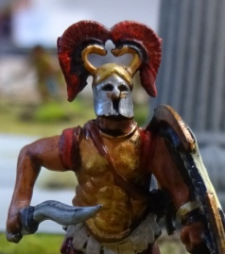
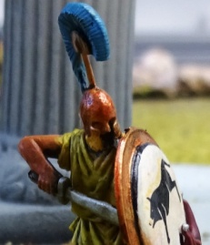
ARGOS
List: Xenophon 75
Cleomenes 64
17 Hoplites 340
5 Hoplites 100
9 Psiloi 72
10 Cretan Archers 150
801 (+6)

TYPE | M | R | MEL | M D | AG | BR | ARM | W | EQUIPMENT
Cleomenes  Argos A | 6" | +1 | +1* | 2D | +1 | +3 | +1 | 2 | Lg Shield, Helmet, Apron, Sword | 64
Wall of Iron* Lethal Blade# Parry 4* Lethal 1# Arm wound -1 melee*
MISS ONE GAME
LEVEL: 1 EXP: 1

TYPE | M | R | MEL | M D | AG | BR | ARM | W | EQUIPMENT
Xenophon  Argos B | 4" | +1 | +2 | 2D | +0 | +3 | +3 | 2 | Cuirass, Lg Shield, Sword | 75
Mighty Blow Reckless Charge Parry 3

LEVEL: 1 EXP: 0

TYPE | M | R | MEL | M D | AG | BR | ARM | W | EQUIPMENT
Hoplite | 5" | +1 | +2 | 2D | +0 | +2 | +2 | 1 | Lg Shield, L Spear, Linothorax, Sword | 20
Parry 2+1

TYPE | M | R | MEL | M D | AG | BR | ARM | W | EQUIPMENT
Psiloi | 6" | +1 | +1 | 1D | +0 | +1 | +0 | 1 | Dagger, 3 Javelins | 8
Hit and Run
TYPE | M | R | MEL | M D | AG | BR | ARM | W | EQUIPMENT
Cretan Archer | 6" | +3 | +1 | 1D | +2 | +1 | +0 | 1 | Bow, Sm Shield, Sword | 15

