Japanese tank prototype rules
Type 4
Cost: 444pts (Inexperienced) 555pts (Regular)
Damage Value: Super Heavy Tank (11+)
Weapons: Turret mounted 140mm Super Heavy
AT Gun, Co-axial MMG and bow MMG
Special rules:
Slow
No reduction in penetration for range
Options:
May add hull-mounted co-axial Low Velocity Light AT Gun + 35 points

Type 3 Chi-Nu Kai

Cost: 184 pts (Inexperienced) 230 pts (Regular)

Damage Value: Medium tank (9+)

Weapons: Turret mounted 75mm Heavy
AT Gun, bow MMG.

Type 5 Chi-Ri
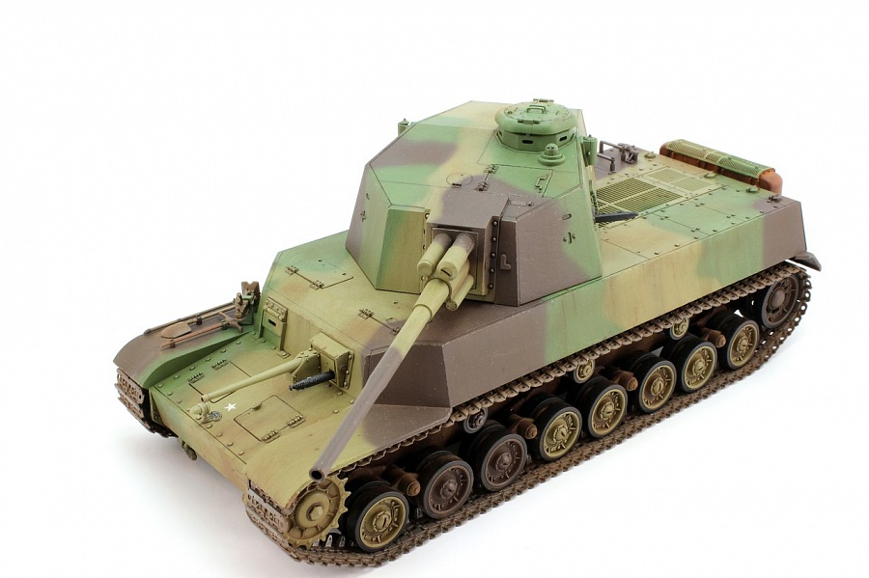
Cost: 280 pts (Inexperienced) 350 pts (Regular)

Damage Value: Medium tank (9+)

Weapons: Turret mounted 88mm Super Heavy
AT Gun, bow MMG.

Special rules:
Extra Frontal armour (10+)

Options:
May add hull-mounted co-axial Low Velocity Light AT Gun + 35 points

Type 5 Ho-Ri I
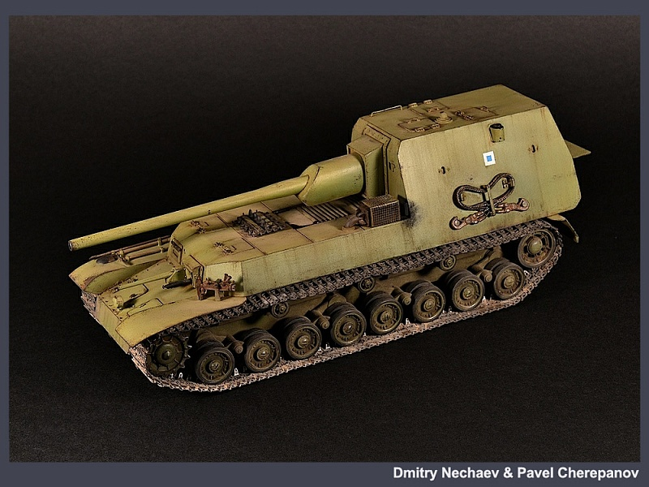
Cost: 244 pts (Inexperienced) 305 pts (Regular)
Damage Value: Medium tank (9+)
Weapons: Turret mounted 105mm Super Heavy
AT Gun, bow MMG.
Options:
May add hull-mounted co-axial Low Velocity Light AT Gun + 35 points

Type 5 Ho-Ri II
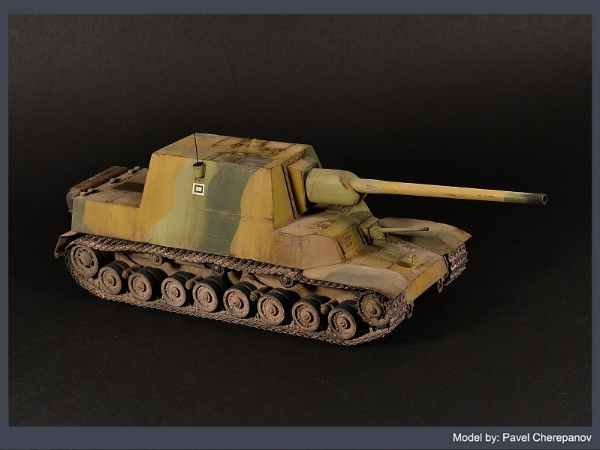
Cost: 276 pts (Inexperienced) 345 pts (Regular)
Damage Value: Medium tank (9+)
Weapons: Turret mounted 105mm Super Heavy
AT Gun, bow MMG.
Special rules:
Extra Frontal armour (10+)
Options:
May add hull-mounted co-axial Low Velocity Light AT Gun + 35 points

